**Sort Questions and Answers**

1. *What is Routing and on which OSI layer it happens?*

Routing is a process which is performed by layer 3 (or network layer) devices in order to deliver the packet by choosing an optimal path from one network to another. There are 3 types of routing:

1. Static routing
2. Default Routing
3. Dynamic Routing

1. *Write any two advantages of static routing.*

Static routing is a process in which we have to manually add routes in routing table. Some advantages of static routing are stated below:

1. No routing overhead for router CPU which means a cheaper router can be used to do routing.
2. It adds security because only administrator can allow routing to particular networks only.

1. *What happens when default routing is applied in networks other than stub networks?*

Default routing is a method where the router is configured to send all packets towards a single router (next hop) and is generally used with stub routers. In networks other than stub networks, if a packet is received on a routing device, the device first checks to see if the IP destination address is on one of the device’s local subnets. If the destination address is not local, the device checks its routing table. If the remote destination subnet is not listed in the routing table, the packet is forwarded to the next hop toward the destination using the default route.

1. *What DCE & DTE stand for?*

*DCE* stands for Data Communications Equipment, and *DTE* stands for Data Terminal Equipment

1. *What OSPF stands for and what is its Metric/Cost?*

OSPF stands for Open Shortest Path First. OSPF uses "Cost" as the value of metric and uses a Reference Bandwidth of 100 Mbps for cost calculation. The formula to calculate the cost is Reference Bandwidth divided by interface bandwidth. For example, in the case of 10 Mbps Ethernet, OSPF Metric Cost value is 100 Mbps / 10 Mbps = 10.

1. *What is the difference between subnet mask and wildcard mask?*

Subnet mask is 32-bit combination used to describe which portion of an address refers to the subnet/network and which part refers to the host. It is used along with IP Address. Whereas Wildcard Mask indicates IOS software whether to check or ignore corresponding IP address bits when comparing the address bits in an access list entry. Wildcard mask is sometimes referred to as an inverted mask because a 1 and 0 mean the opposite of what they mean in a subnet (network) mask.

1. *Differentiate Distance Vector and Link State routing protocols.*

* Bellman-Ford algorithm is used for performing distance vector routing whereas Dijkstra is used for performing the link state routing.
* In distance vector routing the routers receive the topological information from the neighbor point of view. On the contrary, in link state routing the router receive complete information on the network topology.
* Distance vector routing calculates the best route based on the distance (fewest number of hops). As against, Link state routing calculates the best route on the basis of least cost.
* Link state routing updates only the link state while Distance vector routing updates full routing table.
* The utilization of CPU and memory in distance vector routing is lower than the link state routing.

1. *Write one example each of Distance Vector and Link State.*

RIP (Routing Information Protocol) and IGRP (Interior Gateway Routing Protocol) is a commonly used distance vector protocol that uses hop counts or its routing metrics. OSPF (Open Shortest Path First) protocol is the example link state routing.

1. *What is ACL and its Types?*

Access-list (ACL) is a set of rules defined for controlling the network traffic and reducing network attack. ACLs are used to filter traffic based on the set of rules defined for the incoming or outgoing of the network.

There are two main different types of Access-list namely Standard Access-list and Extended Access-list. Furthermore, there are two categories of access list which are Numbered access list and Named access list.

1. *Where we can apply ACL?*

Access Control List (ACL) is placed/configured on the routers to filter the traffic based on source IP address.

***Step no: 1.*** *Use 187.200.1.0/24 address and perform subletting first.*

*Perform OSPF and submit screenshots of all the steps and outputs.*

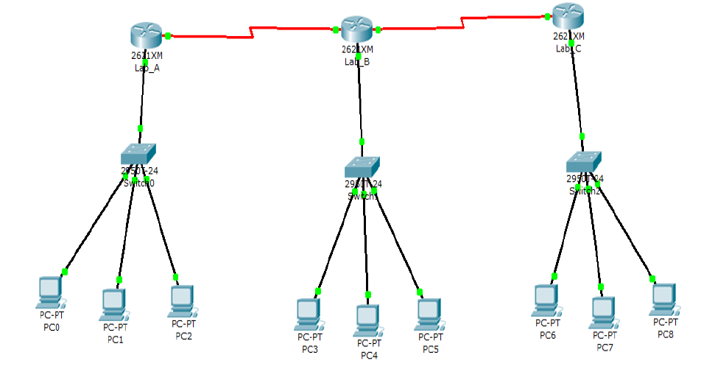

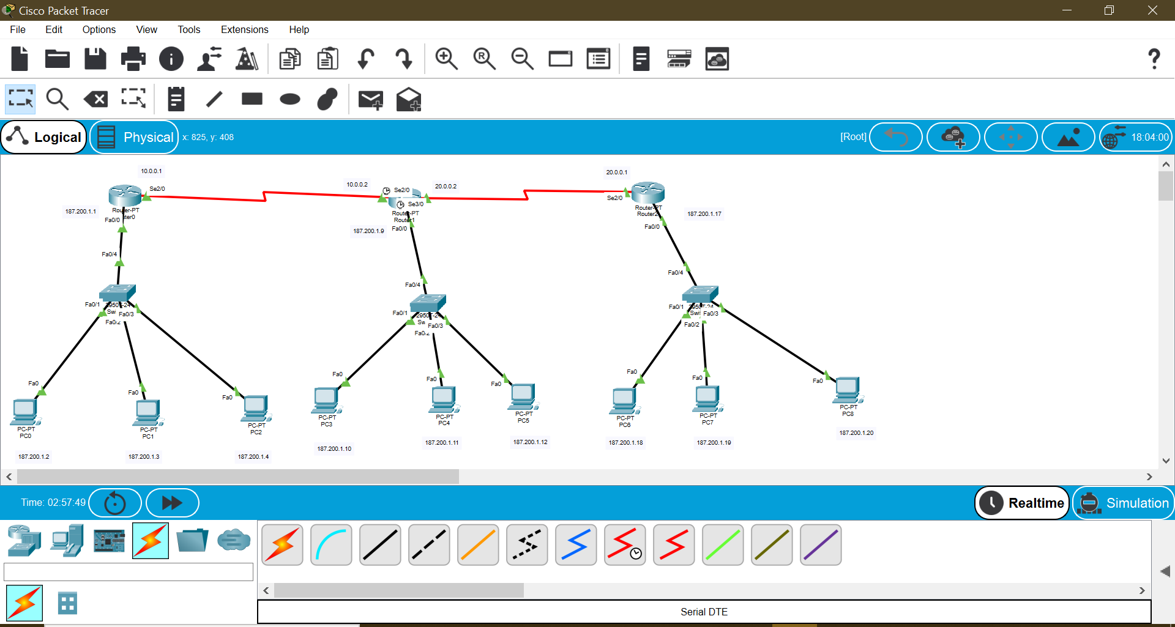

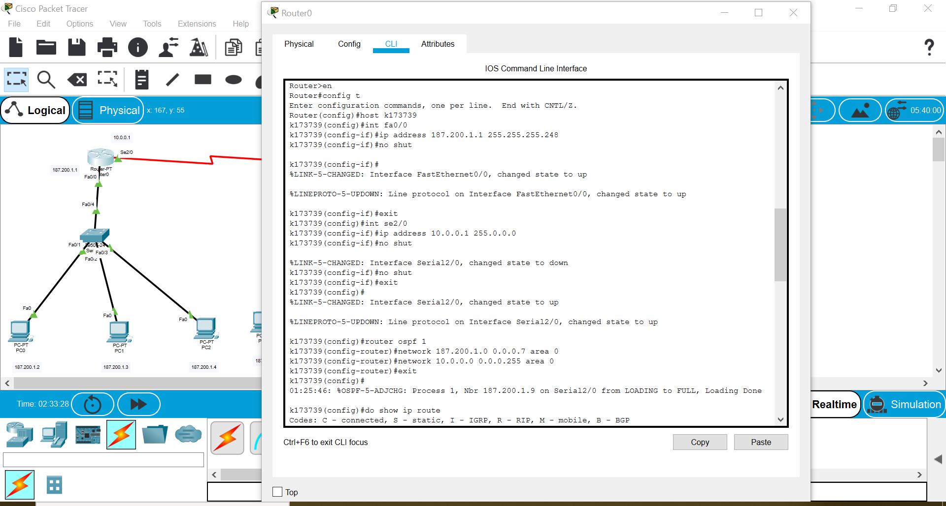

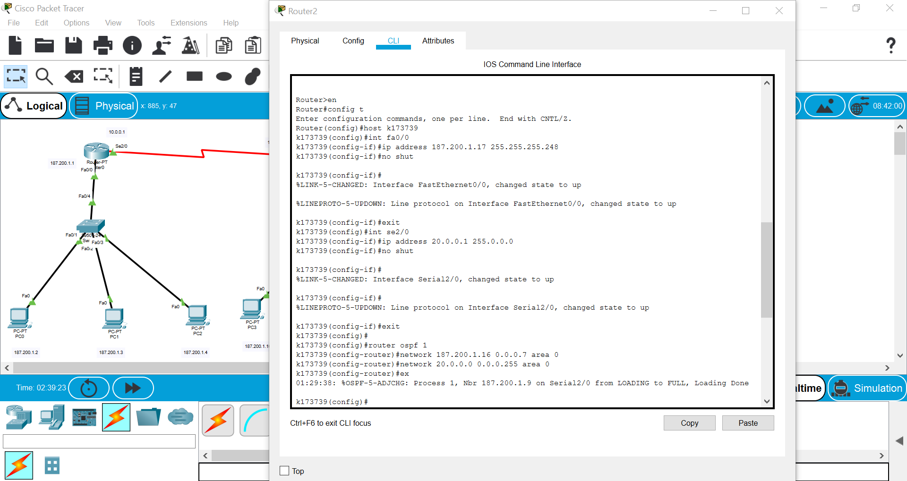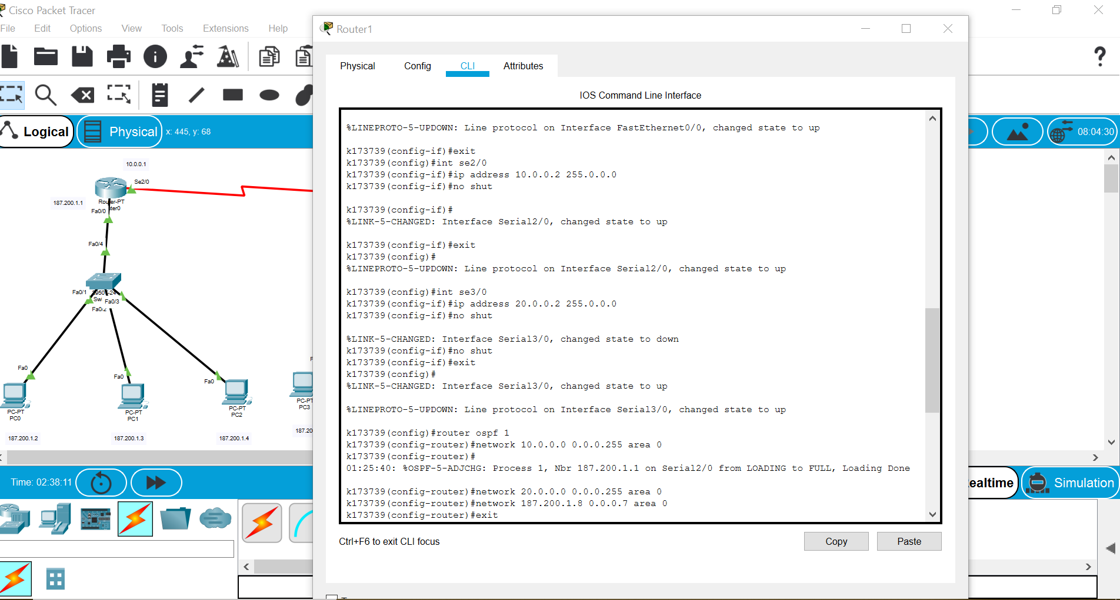

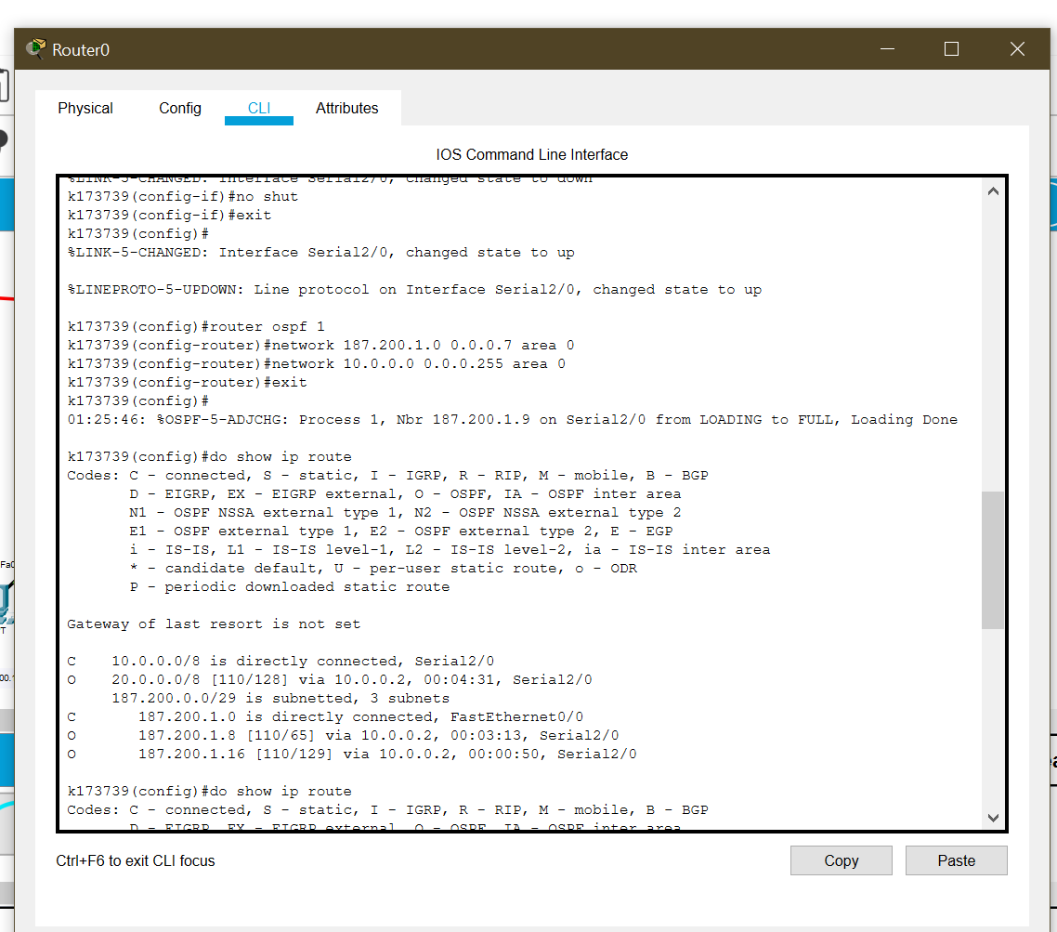

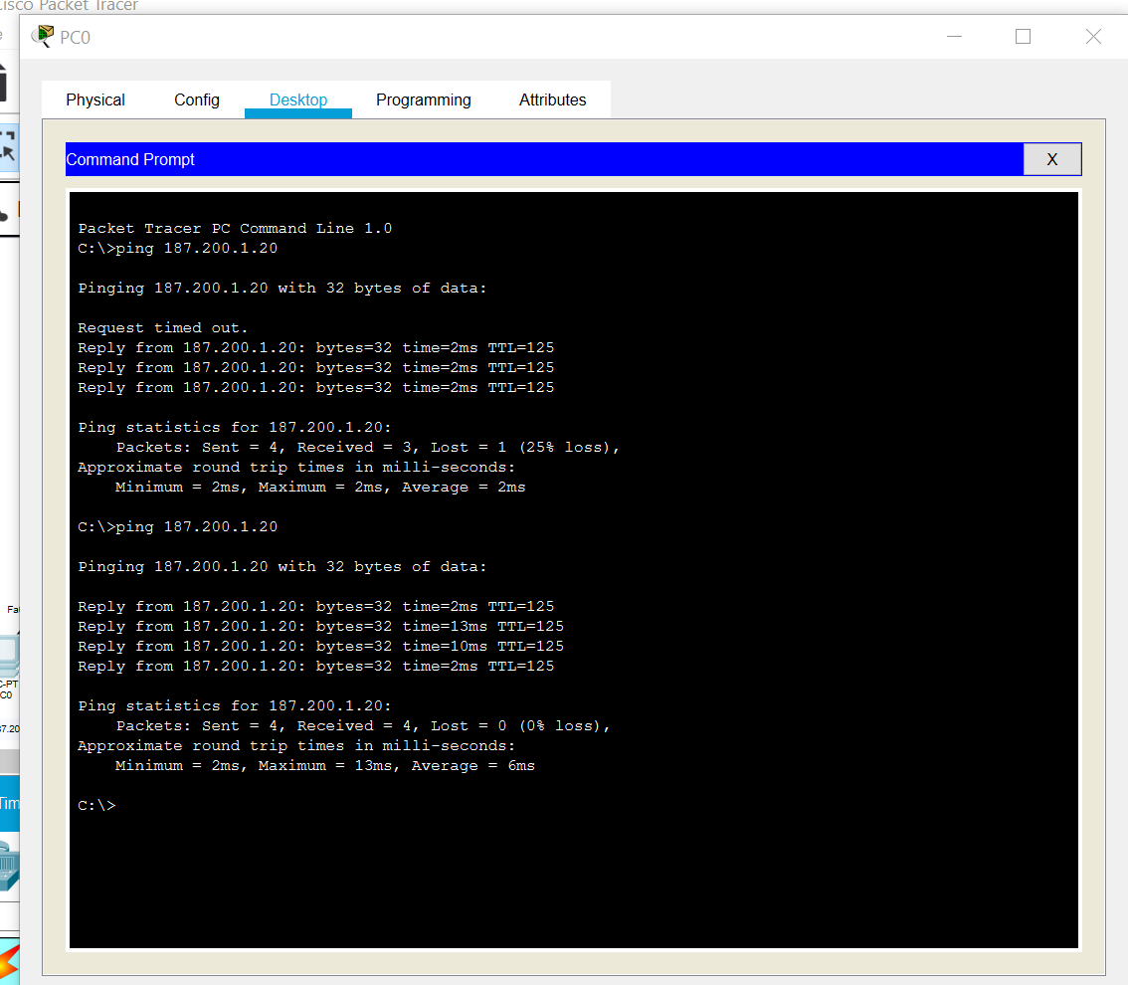

**Step no: 02**. Perform ACL

1. Lab A only wants to communicate with Lab C.

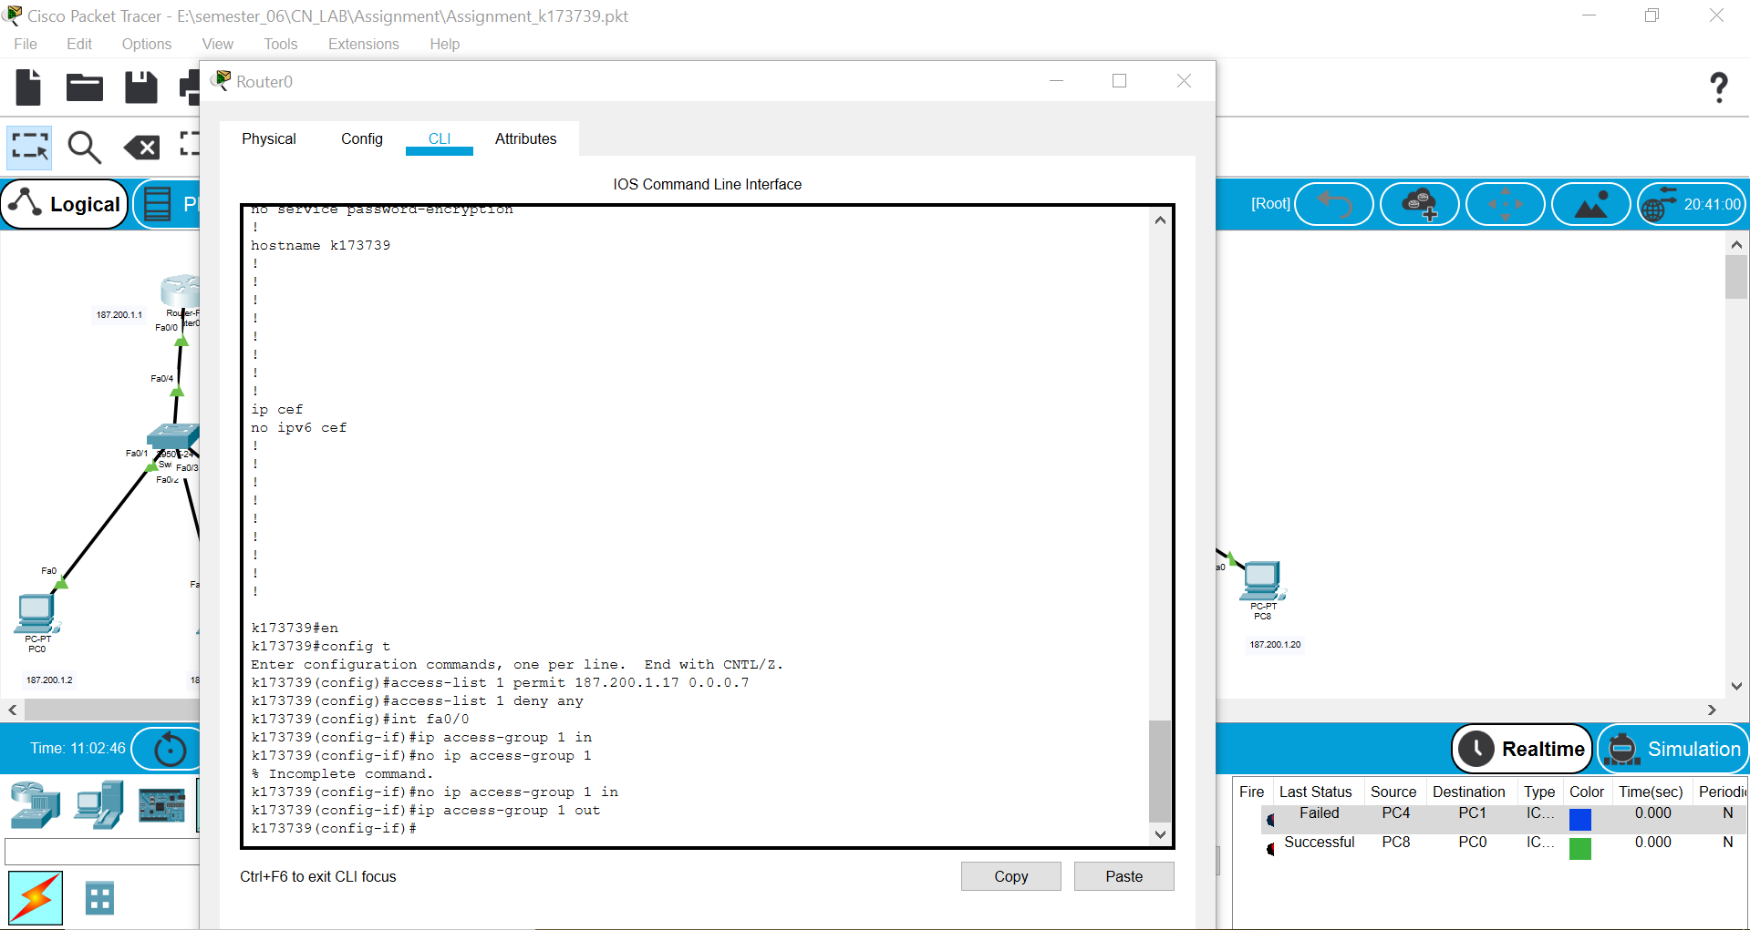

1. Lab C only wants to accept traffic/communicate with PC3 in the Lab B.

